Assignment Report

Course Title: Advance Database system

Course Code: CSE 464

Section : 01

**Group Members:**

* Tahiatul Jannath Bhuiyan
* Farzana Hannan Hera
* Fatema kanam
* Rajashree Roy

**Group ID’s:** 2014-1-60-021,

2014-2-60-031,

2014-2-60-080,

2014-3-60-070.

* **performance Analysis:**
* 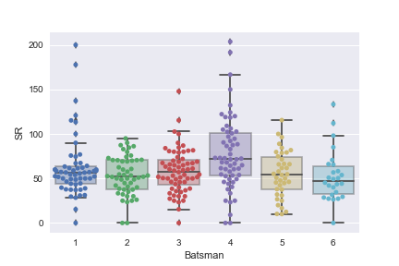**Strike rate:**

As there given 6 players data we plotted all the values in box plot according to strike rate. Here the x-axis shows the players and the y-axis shows the strike rate(run/ball\*100). If we give a close look to the graph player 4 has higher strike rate than other players which around 170.The max and mean value is also higher than other players. On the other hand, player 1 has lower strike rate around 88 though his minimum strike rate is higher around 30 where other player’s minimum strike rates are close to zero. And there are no out layer for player 2 and player 5 where player1 and player4 have high out layer (200) that means those players do well in some cases.

* **Performance Time :**

**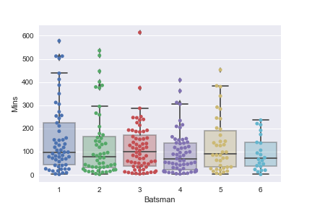**

If we consider the existing time of players in different innings, player1’s maximum time around 445, for player2 its 300 in a same way 298,305,390,245 respectively. Again if we consider 75 percentile rate player1 has around 215, player 2 has 180, player 3 has 185, player4 has 145, player5 295, player6 147 respectively. If we evaluate all the players ‘existing time in different innings player1’s graph result shows better result than other players.

* **Runs vs Batsman :**

**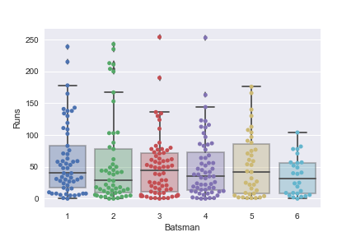**

Let’s consider the run rate of different run rate of the players in different matches. This graph shows that playe1’s run rate around 175, player2’s run rate around 160, payer3 135, payer4 140, player5 175 and palyer5 110 respectively. If we evaluate the graph player1 and player5’ performances are better than the other players in different matches. We also find out layer point for player 3 and player4 that mean they can perform better in some cases.

* **Run with respect to ball face**

**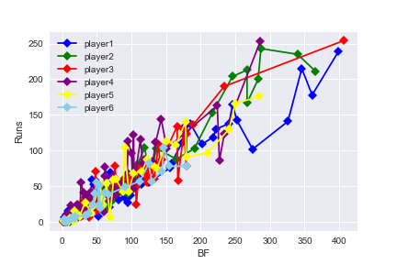**

|  |  |  |
| --- | --- | --- |
| **C:\Users\hp\Desktop\assign\29550511_1104152169724964_260440860_n.png** | **C:\Users\hp\Desktop\assign\29546905_1104152143058300_2111768655_n.png** | **C:\Users\hp\Desktop\assign\29663396_1104152139724967_1999396419_n.png** |
| **C:\Users\hp\Desktop\assign\29547607_1104152156391632_1745731882_n.png** | **C:\Users\hp\Desktop\assign\29666327_1104152136391634_1004553657_n.png** | **C:\Users\hp\Desktop\assign\29550058_1104152133058301_304322855_n.png** |

This graph shows the run with respect to ball faced, here x-axis shows the ball face and y-axis shows runs. Blue points for player1, green points for player2, red points for player3, purple points are for player4, yellow points are for player5, sky blue points for player6. If we closely look up at the graph player 3 has grater run with respect to ball face. All the players have better run initially. Player 1 and player 2 have average consistency because they have also outliers from 200–250 runs based on 300 to 400 ball face which indicates that they can provide better result in future. but other player’s run score are below 200. Player6 has lower run record with respect to ball face comparatively other players.

* **Runs vs 4s**

**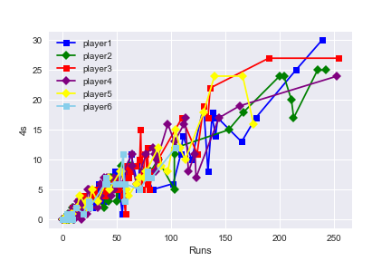**

|  |  |  |
| --- | --- | --- |
| **C:\Users\hp\Desktop\assign\29666206_1104152173058297_359643313_n.png** | **C:\Users\hp\Desktop\assign\29547225_1104152179724963_1804847405_n.png** | **C:\Users\hp\Desktop\assign\29547584_1104152186391629_2041899503_n.png** |
| **C:\Users\hp\Desktop\assign\29745727_1104152193058295_1467089720_n.png** | **C:\Users\hp\Desktop\assign\29663509_1104152196391628_496528650_n.png** | **C:\Users\hp\Desktop\assign\29550844_1104152199724961_1573878835_n.png** |

In this graph, it shows the number of 4s respect to runs. Here x-axis shows the runs and y-axis shows number of 4s runs. Blue points for player1, green points for player2, red points for player3, purple points are for player4, yellow points are for player5, sky blue points for player6. Though we can see, all players have average consistency, the probability of number of 4s is more based on 250-400 ball faced for Player2 but player1, player3, player4 also have outliers.

* **Prediction of career average of 3 batsmen based on sample data using both normal distribution and t-distribution :**

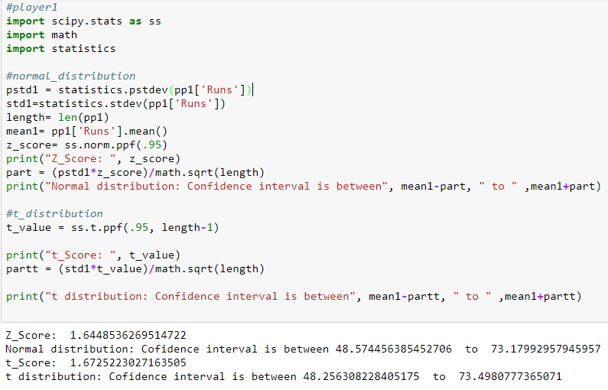

* For player 1 , z-score is 1.644853 which indicates that the confidence interval is between 48.57445 to 73.1799295. Also, t-score is 1.672522 which indicates that confidence interval is between 48.256308 to 73.49807777.

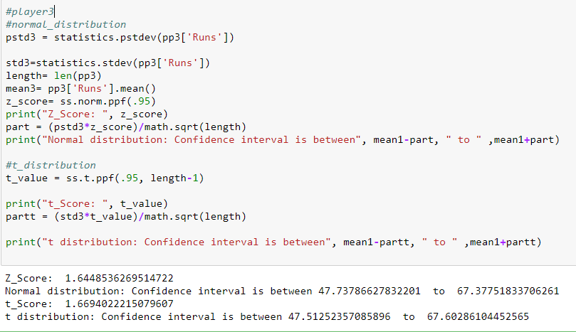

* For player 2 , z-score is 1.644853626 which is same as player1 and t-score is 1.6604022 where confidence interval is between 47.5125235 to 67.60286104.

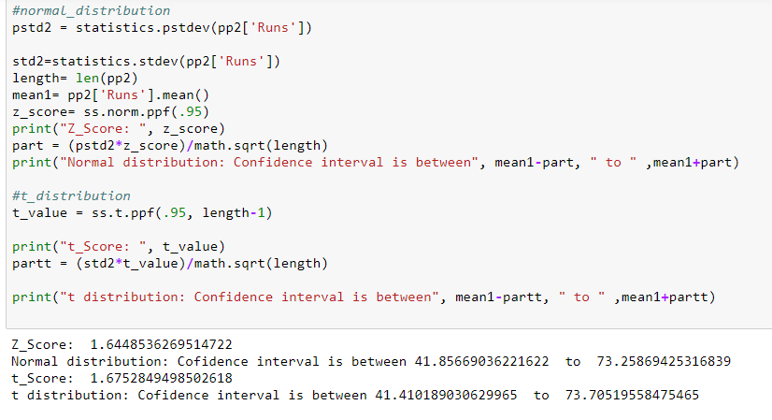

* For player 3 , z-score is 1.644853626 which is same as player1 and player2. Also, t-score is 1.6752849 where confidence interval is between 41.40189 to 73.70519558.
* **Identifying the Batsmen:**

|  |  |  |  |  |  |  |  |  |  |  |  |  |  |  |  |  |  |  |  |  |  |  |  |  |  |  |  |  |  |  |  |  |  |  |  |  |  |  |  |  |  |  |  |
| --- | --- | --- | --- | --- | --- | --- | --- | --- | --- | --- | --- | --- | --- | --- | --- | --- | --- | --- | --- | --- | --- | --- | --- | --- | --- | --- | --- | --- | --- | --- | --- | --- | --- | --- | --- | --- | --- | --- | --- | --- | --- | --- | --- |
| |  |  |  | | --- | --- | --- | | **Players** | **SR AVG** | **Run AVG** | | P1 | 61.9495 | 60.8772 | | P2 | 53.2160 | 57.5577 | | P3 | 58.4177 | 49.0781 | | P4 | 77.6461 | 49.4068 | | P5 | 54.7658 | 53.0263 | | P6 | 52.7150 | 35.7692 | | |  |  |  | | --- | --- | --- | | **Players’ Name** | **Actual SR**  **AVG** | **Actual Run AVG** | | Steven Smith | 55.76 | 63.75 | | Virat Kohli | 58.26 | 53.26 | | AB De Villiers | 54.06 | 49.92 | | David Warner | 74.73 | 48.77 | | Joe Roof | 55.76 | 53.28 | | Tamim Iqbal | 55.51 | 38.68 | |

* Steven Smith has average score 63.75 and average strike rate 55.76 which is similar to player1. Therefore, it can be said player1 is Steven Smith.
* Virat Kohli has average score 53.26 and average strike rate 58.26 which is similar to player2. so it can be said player2 is Virat Kohli.
* AB De Villiers has average score 49.92 and average strike rate 54.06 which is similar to player3. So it can be said player3 is AB De Villiers.
* David Warner has average score 48.77and average strike rate 74.73 which is similar to player4. so it can be said player4 is David Warner.
* Joe Roof has average score 53.28 and average strike rate 55.76 which is similar to player5. so it can be said player5 is Joe Roof.
* Tamim Iqbal has average score 38.68 and average strike rate 55.51 which is similar to player6. so it can be said player6 is Tamim Iqbal.